Oakamoor Community Pub Survey Report

August 2022

Table of Contents
Executive Summary 3
Introduction 4
Background Information 4
Location and Key Characteristics of Oakamoor 4
Demographics 5
Tourism 6
Aim & Objectives 7
Methodology 7
The Questionnaire 7
1. Do you live in Oakamoor? 8
2. If you do not live in Oakamoor, how far away do you live? 8
3. What age group do you fit into - are you? 8
4. What do you think are the most important aspects of a village pub? Select as many as you like. 8
5. How often do you visit a pub? 8
6. Are there any other services you would like to see in a village pub offer? (such as community shop, meeting space, cafe, book exchange etc.) 9
7. What do you think about a village pub being managed as a community pub? Is it a good idea? 9
8. Would you be interested in investing in a community pub? 10
9. Would you like to see the results of this questionnaire? 10
10. Email address 10
Distribution 10
Findings 10
Conclusion 13
Appendix 1 – Responses to “Other Services” Question 14

Executive Summary
A small group of people in Oakamoor, Staffordshire Moorlands have come together to assess the interest and potential level of support in Oakamoor for a community purchase and management the village pub.
A survey, using an online questionnaire was used to assess the level of support for the idea of the village pub being owned and managed by the community. The results of this clearly indicate that there is both support for the idea of a community pub and a willingness to invest in one. 106 responses were received and all responded with either “Yes” or “Maybe” to the idea of a village pub being owned and manged by the community. When asked whether they would consider investing in a community pub, again there was a positive response. 90 respondents replied either “Yes” or “Maybe” to a question asking them if they would consider investing in a community pub and, perhaps more importantly, this figure only reduced to 84 when responses were filtered to include only respondents who either live in Oakamoor or within a 5-10 minute drive of Oakamoor.
Other questions in the questionnaire were posed to assess what respondents felt were important in a village pub and how it might better serve the community. With the exception of one respondent, all rated a “friendly welcome” as being important in a village pub and, despite all the pubs that have existed in the village being focussed on beer sales, there was considerable support for diversification of the business. In total, there were 134 suggestions in response to what other things the pub could offer. To analyse these responses, they were grouped into six categories; a shop, music related, book exchange, food related, a meeting space and an “other” category. The top three suggestions were a Café operation, a shop (the village does not have one) and a community meeting space. All three of these imply a desire for a longer opening period than the one currently on offer at the village pub.
This report will be presented to a charitable organisation called the Plunkett Foundation which assists communities in the set up and running of community businesses.

Introduction
This report has been prepared to detail the findings of a survey to assess the interest and potential level of support of the community in Oakamoor, Staffordshire Moorlands to purchase and manage a community pub. The village used to have three public houses within the village but now has only one and the owner this has indicated a desire to retire in the near future. The property has previously been offered for sale, but interest was low and the only offer made, was withdrawn due to a lack of funds. Not wishing to lose the last pub in the village, a small group of people have come together as a project group to examine how they might ensure that this does not happen.

Background Information

Location and Key Characteristics of Oakamoor
The village of Oakamoor lies approximately 13 miles east of Stoke on Trent and is within the Churnet Valley, which follows a route running from Cheddleton to Denstone. Although only properly settled from the early 19th century, the settlement, located at a major east-west crossing point of the river, saw significant levels of industrial activity from the 13th century onwards.
Figure 1 - Village Location
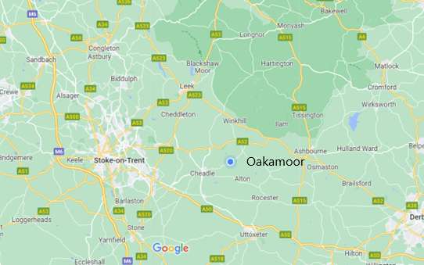
The key characteristics of the parish include the following:
- situated within a conservation area;
- a scenic wooded environment, dominated by a dense tree canopy of mixed planting (native deciduous and conifers);
- dominated by the River Churnet, which is the focus of most historic industrial activity and has influenced the linear form of housing development;
- dramatic, memorable views and relationships between the River Churnet and engineered structures, such as the bridge and weir and the Churnet Valley Railway bridges and tunnel;
- an awareness of the natural beauty of the environment has influenced the design, orientation and location of buildings – picturesque groups of cottages and detached villas are scattered along the roads; and
- there are large areas of recreational public open space, and a good public footpath network which provides a high-quality environment with generous access for walkers, cyclists and horse riding, and sporting leisure interest, such as cricket.

Demographics
According to an Office for National Statistics estimate in 2020, Oakamoor parish had a total population of 579, with a fairly even gender split (53% male & 47% female). The age distribution the parish is shown in Table 1 below. With 64.6% of the population being 50+ years old, it is believed that this is slightly more aged than the average for the UK. This does, however, mean that in excess of 97% (493) of the local population are of an age where they could legally purchase alcohol.
Table 1 - Age Distribution of Oakamoor Parish
Age Distribution (ONS Estimate 2020) | Number | Percentage
0-9 years | 28 | 5.5%
10-19 years | 55 | 10.8%
20-29 years | 41 | 8.1%
30-39 years | 42 | 8.3%
40-49 years | 81 | 15.9%
50-59 years | 123 | 24.2%
60-69 years | 95 | 18.7%
70-79 years | 79 | 15.5%
80+ years | 32 | 6.3%

With regard to ethnicity, the 2011 Census reveals that the parish is almost entirely white (99%) with the country of birth identified as the United Kingdom (98%).
Using a central village postcode (ST10 3AB) the village is identified as Type 26: Semi-Professional Families, Owner Occupied Neighbourhoods within the CACI Acorn profiles. CACI summarises this profile as an area where “more than average of the couples are well educated and in managerial occupations, these streets will contain a broad mix of people. Most have above average incomes with a few people paying higher rate tax. They generally have modest savings and some investments. Relatively few will have loans or other borrowing, but some might occasionally utilise the overdraft on their current account. Generally, the property is being bought with a mortgage, and in many cases mortgages have been repaid for more than 10 years”.
Also, of particular relevance to this study are the CACI assessments of Household Income (Figure 2) and Community Engagement (Figure 3). These indicate a higher than average (100 being the average) household income and a high level of interest in community initiatives.
Figure 2 - CACI Type 26 Household Income Assessment
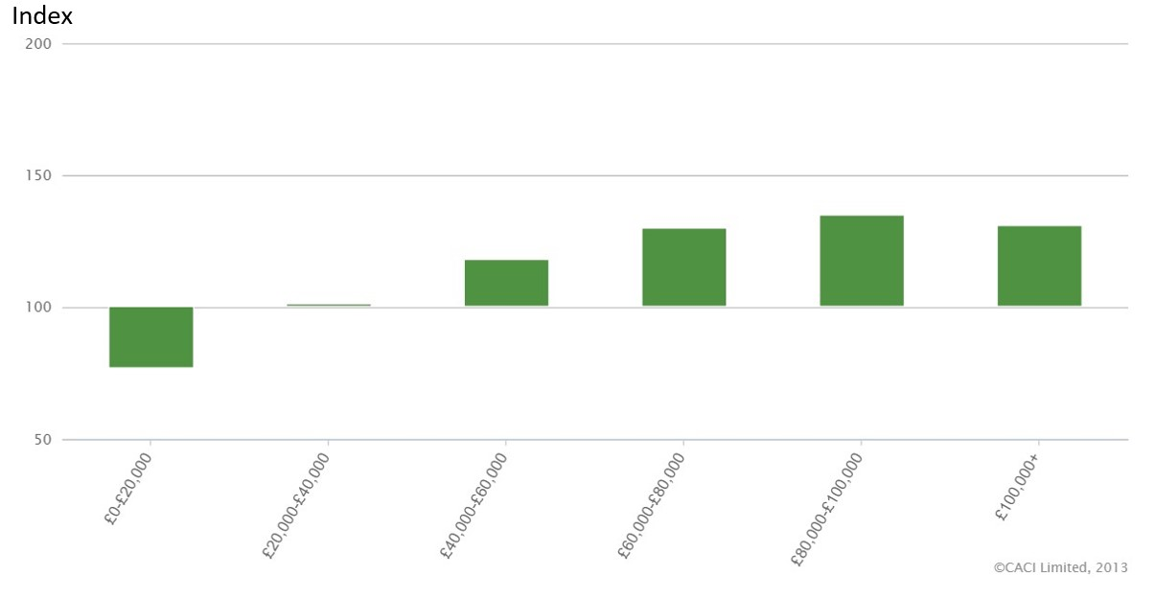
Figure 3 - CACI Type 26 Community Engagement Assessment
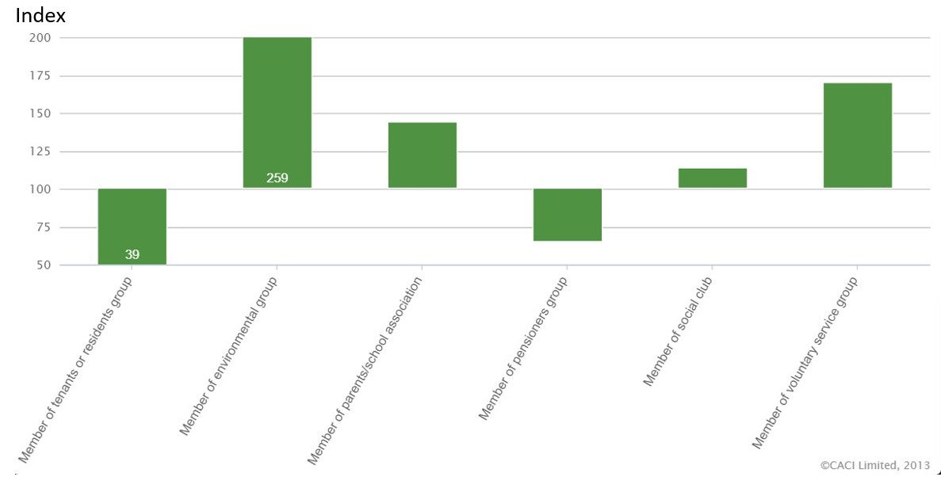

Tourism
In additional to the resident population, the area witnesses significant tourism with visitors attracted by the Alton Towers Theme Park, the Ramblers Retreat Tea Rooms, Cotton Dell Nature Reserve, the Oakamoor to Denstone Greenway and two large campsites within the area.

Aim & Objectives
The group has made contact with the Plunkett Foundation, which is a national charity that supports rural communities in the set up and running of community businesses. In order to benefit from its support, the group needs to demonstrate that there is sufficient local support for the idea of the pub being owned and managed by the community. Therefore, the aim of the study is:
To assess the level of support for the idea of the village pub being owned and managed by the community.
In order to satisfy this aim, four objectives of the study have been identified. These are:
- To identify whether the local population supports the idea of community ownership;
- to identify whether that interest translates into a willingness to invest in a community business;
- to identify what people would consider important in a village pub; and
- to examine how people thought the business could better benefit the community.

Methodology
Given the somewhat narrow aim of the study, it was decided that this could be achieved using relatively few questions in an online questionnaire. Whilst it was accepted that not everyone has access to the internet, it was felt that at this stage of the project, we would be able to generate a sufficient level of responses to achieve the aim and objectives. That said, in addition to encouraging people to complete the online questionnaire, in some instances the questions were presented face to face and the results recorded using a mobile device. The online questionnaire was available for the three weeks leading up to 7th August 2022.

The Questionnaire
As stated above, the intention was to keep the questionnaire as simple as possible and not expect people to spend too much time completing it. The final version of the questionnaire consisted of ten questions which, broadly speaking, sought to:
- To categorise the respondent by location;
- to identify their pub usage and allow them to express their views on village pubs; and
- to allow them to express whether they supported the idea of a community pub and would be prepared to invest in one.
Respondents were informed of the purpose of the questionnaire through the following statement:
A small group of people in Oakamoor are considering organising the purchase of the local public house, if it becomes available, and to run it as a community business. This questionnaire has been put together to discover what people would expect from a village pub. The questions shouldn't take more than 5 minutes to complete. All responses will remain anonymous, unless you provide us with an email address, and there are no wrong answers so tell us what you really think!
Specifically, the questions were as follows:

Do you live in Oakamoor?
This question was asked to identify and analyse later responses to those who lived in the village. Responses to this question were restricted to a simple Yes/No choice.

If you do not live in Oakamoor, how far away do you live?
Respondents were only asked this question if the said No to question one. Given the rural location of the village, it was accepted that some respondents would not live in it and, therefore, this question sought to identify how far from the village they lived. Possible responses were:
- 5-10 minute drive away;
- 10-20 minute drive away; and
- more than 20 minutes drive away.

What age group do you fit into - are you?
This question sought simply to identify a broad definition of the respondents age to enable analysis of future responses. The options were:
- Young (under 30);
- Youngish (30 to 50);
- Less Young (you're 50-70); and
- Not young (70+).

What do you think are the most important aspects of a village pub? Select as many as you like.
Respondents were presented with six choices in this question and could select as many of them as they thought relevant. The question was asked to assess what respondents thought were important aspects of a village pub because the current offer, and those of the two that have now closed, is/were predominately focussed on beer sales. Information gained through this question would enable the group to further understand the expectations of the respondents in respect of a village pub. The choices were:
- a good beer offer;
- a friendly welcome;
- a good food offer;
- pub games (pool/darts);
- beer garden; and
- live music nights.

How often do you visit a pub?
Obviously, the current pub visiting habits of the respondents was of particular interest to the group. A recent study published on www.statista.com (Figure 4) reveals that over 2021, approximately one third of people visit a pub once a fortnight and 10% visit once a week or more. Again, further analysis based on the responses to this question can be undertaken. The choices presented were:
- Several times a week;
- Once a week (on average);
- Once/twice a month;
- Very occasionally; and
- Never visit a pub.
Figure 4 - Frequency of Britons buying food and drinks in pubs from 2019 and 2021 (www.statista.com)
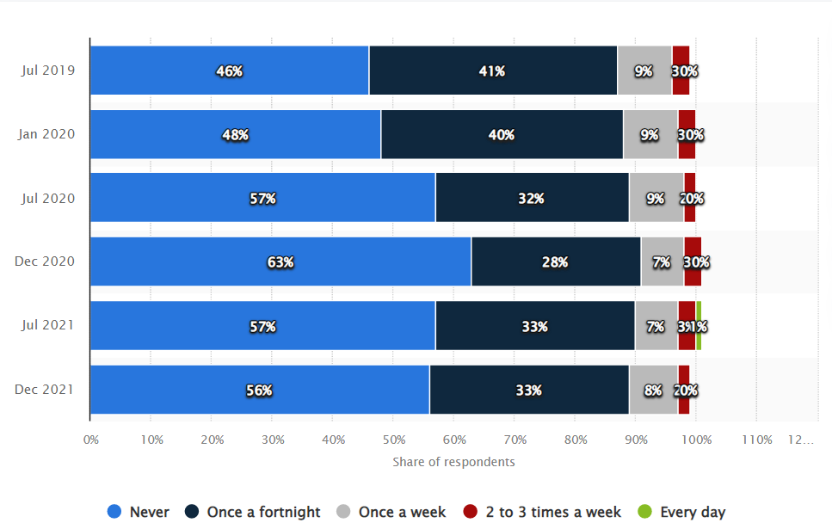

Are there any other services you would like to see in a village pub offer? (such as community shop, meeting space, cafe, book exchange etc.)
This question was included to assess how respondents reacted to a pub being “more than a pub”. Whilst suggestions were made within the question, responses were completely unrestricted.

What do you think about a village pub being managed as a community pub? Is it a good idea?
This is a straightforward and direct question that will contribute significantly to the aim and objectives of this study. It was originally intended to be a straight Yes/No choice but after consideration, given the very limited information on which to make this decision, a Maybe option was included.

Would you be interested in investing in a community pub?
Again, a straightforward question that will contribute significantly to the aim and objectives of this study. It too was originally intended to be a straight Yes/No choice but after consideration, given the very limited information on which to make this decision, a Maybe option was included.

Would you like to see the results of this questionnaire?
A simple Yes/No question that will allow an assessment of the level of interest in the project.

Email address
Primarily for those answering Yes to question 9. However, if others provide this information, it may have value in the future.

Distribution
People were made aware of the survey via a poster within the local pub, word of mouth and social media. In addition, people attending a local music event and some people visiting the pub were presented with the questions face to face and their responses recorded using a mobile device.

Findings
In total, 106 people completed the questionnaire and the majority (75.5%) considered themselves to be residents of Oakamoor (Table 2). Of the remainder, another 14 people lived within 5-10 minute drive.
Table 2 - Respondents by Geographic Location
Live in Oakamoor | 80 | 75.5%
5-10 minute drive away | 14 | 13.2%
10-20 minute drive away | 5 | 4.7%
more than 20 minutes drive away | 7 | 6.6%
Grand Total | 106 | 100.0%

The ages of the respondents were as shown in Table 3.
Table 3- Age of Respondents
Young (under 30) | 6 | 5.7%
Youngish (30 to 50) | 24 | 22.6%
Less Young (you're 50-70) | 68 | 64.2%
Not young (70+) | 8 | 7.5%
Grand Total | 106 | 100.0%

The information in Tables 2 & 3 gives confidence in the fact that the views expressed are predominantly those of the local community and that the respondents are, broadly speaking, representative of the Oakamoor parish.
The responses regarding pub visiting are particularly relevant to the project. Tables 3 & 4 show the responses for all respondents (Table 4) and then filtered to only Oakamoor residents and those living within a 5-10 minute drive.
Table 4 - Pub Visiting (All Respondents)
Several times a week | 48 | 45.3%
Once a week (on average) | 30 | 28.3%
Once/twice a month | 20 | 18.9%
Very occasionally | 8 | 7.5%
Grand Total | 106 | 100.0%

Table 5 - Pub Visiting (Oakamoor + 5-10 Minute Drive)
Several times a week | 43 | 45.7%
Once a week (on average) | 29 | 30.9%
Once/twice a month | 16 | 17.0%
Very occasionally | 6 | 6.4%
Grand Total | 94 | 100.0%

Comparing these results with the statista.com results, it seems that the local propensity for pub visiting is much higher than the UK average. Of all respondents the percentage visiting a pub once a week or more is 73.6% and this rises to 76.6% when filtered by Oakamoor + 5-10 Minute Drive. These figures far exceed the 33% figure in the statista.com survey and the figures for “several times a week” at 45%+ are particularly encouraging.
The responses to the question regarding what respondents see the most important aspects of a village pub, provide some interesting results (Figure 5). As previously stated, pubs within the village have focussed mainly on beer sales. These responses indicate that there is a much wider expectation of what a village pub should offer.
Figure 5 - Responses to " What do you think are the most important aspects of a village pub?”
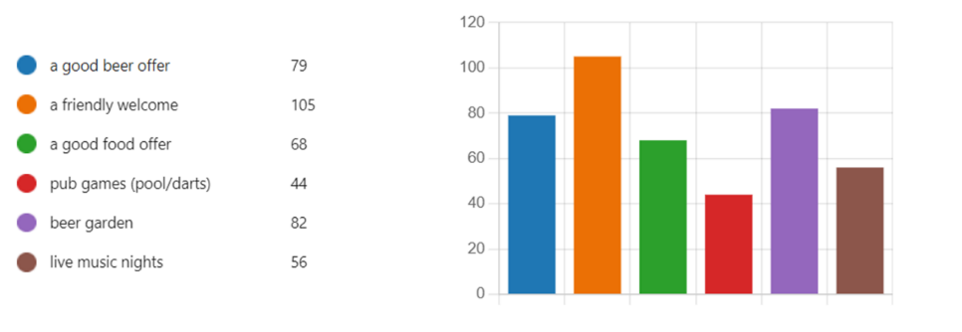
Question 6 “Are there any other services you would like to see in a village pub offer? (such as community shop, meeting space, cafe, book exchange etc.)” was a completely open question and resulted in a wide range of responses (see Appendix 1). To analyse these responses, they have been grouped into six categories; a shop, music related, book exchange, food related, a meeting space and an “other” category. In total, there were 134 suggestions and the categorised breakdown of these is shown in Figure 6 below.
Figure 6 - Responses to "Are there any other services you would like to see in a village pub offer?

The responses to the question on whether a community pub was a good idea revealed that 73.6% (78) thought it was a good idea and the remaining 26.4% (28) thought it was “Maybe” a good idea (Figure 7).
Figure 7 - Responses to "What do you think about a village pub being managed as a community pub? Is it a good idea?"


Perhaps the most important question in the questionnaire was the one where respondents were asked if they would consider investing in a community pub. Examining this initially for all respondents (Figure 8), 39 (36.8%) said “Yes” and 51 (48.1%) said “Maybe”. When looking at this for respondents who live in Oakamoor or within a 5-10 minute drive, the figures are even more positive (Table 6). The “Yes” response increases to 37.2% and the “Maybe” response also increases to 51.1%. 83 of the 94 people within this group would consider investing in a community pub.
Figure 8 - "Would you consider investing in a community pub? (All respondents)
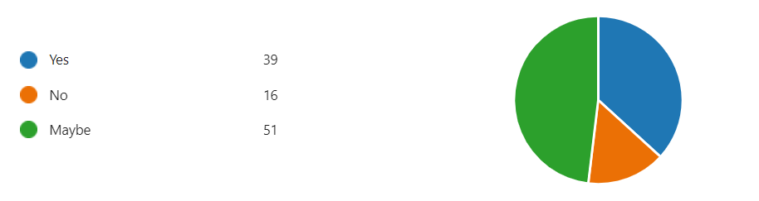
Table 6 - "Would you consider investing in a community pub? (Oakamoor & 5-10 minute drive)
Yes | 35 | 37.2%
Maybe | 48 | 51.1%
No | 11 | 11.7%
Grand Total | 94 | 100.0%

Conclusion
The aim and objectives of this study have been met and there is clear evidence, given the responses to question 7 (What do you think about a village pub being managed as a community pub?) which were 100% Yes or Maybe, that the local population supports the idea of community ownership. In addition, responses to question 8 (Would you be interested in investing in a community pub?), with 83 out of 94 respondents who live in Oakamoor or within a 5-10 minute drive, indicates that the support for a community run pub, does translate into a willingness to invest in a community business.
The survey, through the responses to questions on what people see as important in a village pub and what services could be added to increase community use, also demonstrates that the community is willing to seeing the pub as “more than a pub”.
Also, the above average propensity in pub visiting is a positive result for the project.

Appendix 1 – Responses to “Other Services” Question
Community shop
A community pub needs to be big enough to offer a diverse range of products - drink- food- local leagues- events (like the white Hart). Cricketers is not big enough and does not have sufficient potential to be a successful community owned pub
Acoustic music
All covered above
All of the above
All of the above
All of these
All the above
Bar Snacks
Basics shop and newspapers , coffee and snacks
Book exchange
Book exchange. Shop.
Cafe
Cafe
Cafe /shop/pizza oven
Cafe and meeting space
Café and shop would be good
Cafe, basic shopping items
Cafe, book exchange shop
Cafe, community shop, book exchange, meeting space, something for youngsters too (not sure what)
Cafe, meeting space for community groups, book exchange
Cafe/brunch place
Community shop
Community shop would be helpful
community shop, cafe
Community shop, pensioners lunch club, book club, afternoon activities e.g. bingo, tea and cakes
Community shop, something for the elderly people, i.e. knit and natter, coffee mornings
Community shop/cafe
Community shop/cafe.
Daytime cafe. Meeting place
Essential shopping (milk, bread)
Fit bar staff
If they did food for the walkers and what not it would be nice
Just a good pub with good beer
Meeting space
Meeting space
Meeting space/ morning coffee/ good food/book exchange /village hub
N/a
No
No. Re - food. I appreciate that the cricketers doesn’t have a kitchen big enough to offer a full menu. But in the past things like beef baps, chips, pies - simple food that can be pre prepared has gone down well and would help attract footfall from walkers and tourists.
Not really
Open in the day. Coffee cake. Get togethers
Shop
Shop cafe
Shop for basics, papers etc, coffee, cake and ice creams
Shop would be good
shop, cafe
Shop, cafe, post office
Shop, meeting space, book exchange
Shop, weekly /monthly theme night, clubs,
Shop. Cafe in the day. Meeting place
Smile
Tea room
The pub is central to the community. As so it would be good to be used as a centre for community activities outside of normal pub times
Trips out
Village shop
Would be good to have a shop.
Yes above plus sub post office.
Yes to all of the examples listed, maybe even have a drop in session from advice agencies such as CAB. Also other village pubs offer clubs etc on a regular basis such as reading groups, art and so on or a venue for U2A.
accommodation
All of these
Books, meeting space for local people .
Cafe
Cafe, meeting space
Choice of hot and cold buffet food for Birthday parties etc
Coffee shop
Community arts centre…
Community meeting space
Community place
Community shop
Community shop if there is not one in the village already
Good opening hours
I don't live in the UK, visit quite often. With no other cafes in the area, I think a cafe would work, especially for walkers. A shop.
Meeting space
Meeting space for local groups
Meeting space. Cafe. Open in the day
No
Open in the day. Small cafe
Post office
Shop, post office, snack menu
Welcome horses for pub crawl

